Using the Four- and Eight-Tab Foldable
Adapt the Four-Tab Foldable to review digraphs, blends, and vowel variant letter-sounds. Open the tabs and qrite a CCVC or CVCe word on the bottom paper so that one letter is shown in each box. Have students practice blending, decoding, and identifying words.
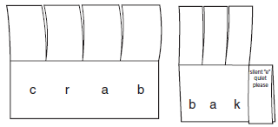
Another option is to make the Foldable with three tabs. At step 3 (see page 34), cut only the first and the third creases so that the middle tab is twice the size of the other two tabs. Open all three tabs and write a word with a vowel digraph or a CVVC word on the bottom paper so that one letter is shown in each box and so that the middle two letters will be hidden by the middle tab.
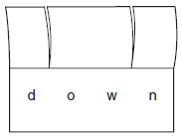
Or, cut only the first and second tabs and write a word that ends with double letters or the digraph-ck.
